**Bahria University,**

Karachi Campus



## LAB EXPERIMENT NO.

## 4

## LIST OF TASKS

|  |  |
| --- | --- |
| **TASK NO** | **OBJECTIVE** |
| **1** | Using python implement Decision Tree Algorithm on Diabetes Dataset the chances of diabetes in a person. visualize the results of the model in the form of a confusion matrix using matplotlib and seaborn. |
| **2** | Using python perform the parameter tuning to optimize the Decision Tree performance and compare the results with task # 1. |

**Submitted On:**

18 feb 2024

(Date: DD/MM/YY)

**TASK 1:** Using python implement Decision Tree Algorithm on Diabetes Dataset the chances of diabetes in a person. visualize the results of the model in the form of a confusion matrix using matplotlib and seaborn.

from sklearn.tree import DecisionTreeClassifier

from sklearn.metrics import confusion_matrix, accuracy_score

import matplotlib.pyplot as plt

import seaborn as sns

from sklearn.preprocessing import StandardScaler

from sklearn.model_selection import train_test_split

import pandas as pd

file_path = 'diabetes.csv'

diabetes_data = pd.read_csv(file_path)

columns_to_fix = ['Glucose', 'BloodPressure', 'SkinThickness', 'Insulin', 'BMI']

for col in columns_to_fix:

    diabetes_data[col] = diabetes_data[col].replace(0, diabetes_data[col].median())

X = diabetes_data.drop('Outcome', axis=1)

y = diabetes_data['Outcome']

X_train, X_test, y_train, y_test = train_test_split(X, y, test_size=0.2, random_state=42)

scaler = StandardScaler()

X_train_scaled = scaler.fit_transform(X_train)

X_test_scaled = scaler.transform(X_test)

dt_classifier = DecisionTreeClassifier(random_state=42)

dt_classifier.fit(X_train_scaled, y_train)

y_pred = dt_classifier.predict(X_test_scaled)

accuracy = accuracy_score(y_test, y_pred)

conf_matrix = confusion_matrix(y_test, y_pred)

plt.figure(figsize=(8, 6))

sns.heatmap(conf_matrix, annot=True, fmt='d', cmap='Blues')

plt.title('Confusion Matrix for Decision Tree Model')

plt.xlabel('Predicted Labels')

plt.ylabel('True Labels')

plt.show()

print(f"Accuracy of the Decision Tree model: {accuracy:.2f}")

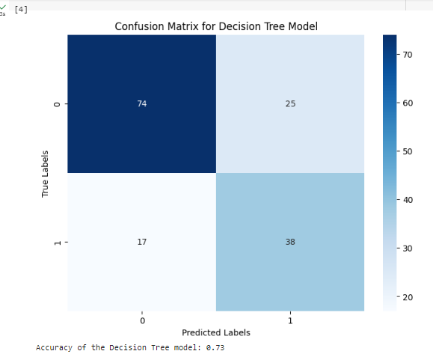

**TASK # 2:** Using python perform the parameter tuning to optimize the Decision Tree performance and compare the results with task # 1.

from sklearn.model_selection import GridSearchCV

param_grid = {

    'criterion': ['gini', 'entropy'],

    'max_depth': [None, 10, 20, 30, 40, 50],

    'min_samples_split': [2, 5, 10],

    'min_samples_leaf': [1, 2, 4]

}

grid_search = GridSearchCV(DecisionTreeClassifier(random_state=42), param_grid, cv=5, scoring='accuracy', n_jobs=-1)

grid_search.fit(X_train_scaled, y_train)

best_params = grid_search.best_params_

print(f"Best parameters: {best_params}")

optimized_dt = DecisionTreeClassifier(**best_params, random_state=42)

optimized_dt.fit(X_train_scaled, y_train)

y_pred_optimized = optimized_dt.predict(X_test_scaled)

accuracy_optimized = accuracy_score(y_test, y_pred_optimized)

confusion_mtx_optimized = confusion_matrix(y_test, y_pred_optimized)

plt.figure(figsize=(8, 6))

sns.heatmap(confusion_mtx_optimized, annot=True, fmt='d', cmap='Blues')

plt.title('Confusion Matrix for Optimized Decision Tree Model')

plt.xlabel('Predicted labels')

plt.ylabel('True labels')

plt.show()

print(f"Accuracy before optimization: {accuracy:.2f}")

print(f"Accuracy after optimization: {accuracy_optimized:.2f}")

accuracy_improvement = accuracy_optimized - accuracy

accuracy_improvement

